**Ideation Phase**

**Empathize & Discover**

|  |  |
| --- | --- |
| Date | 23 September 2022 |
| Team ID | PNT2022TMID50136 |
| Project Name | Project –Statistical Machine Learning Approaches to liver Disease Prediction |
| Maximum Marks | 4 Marks |

**Empathy Map Canvas:**

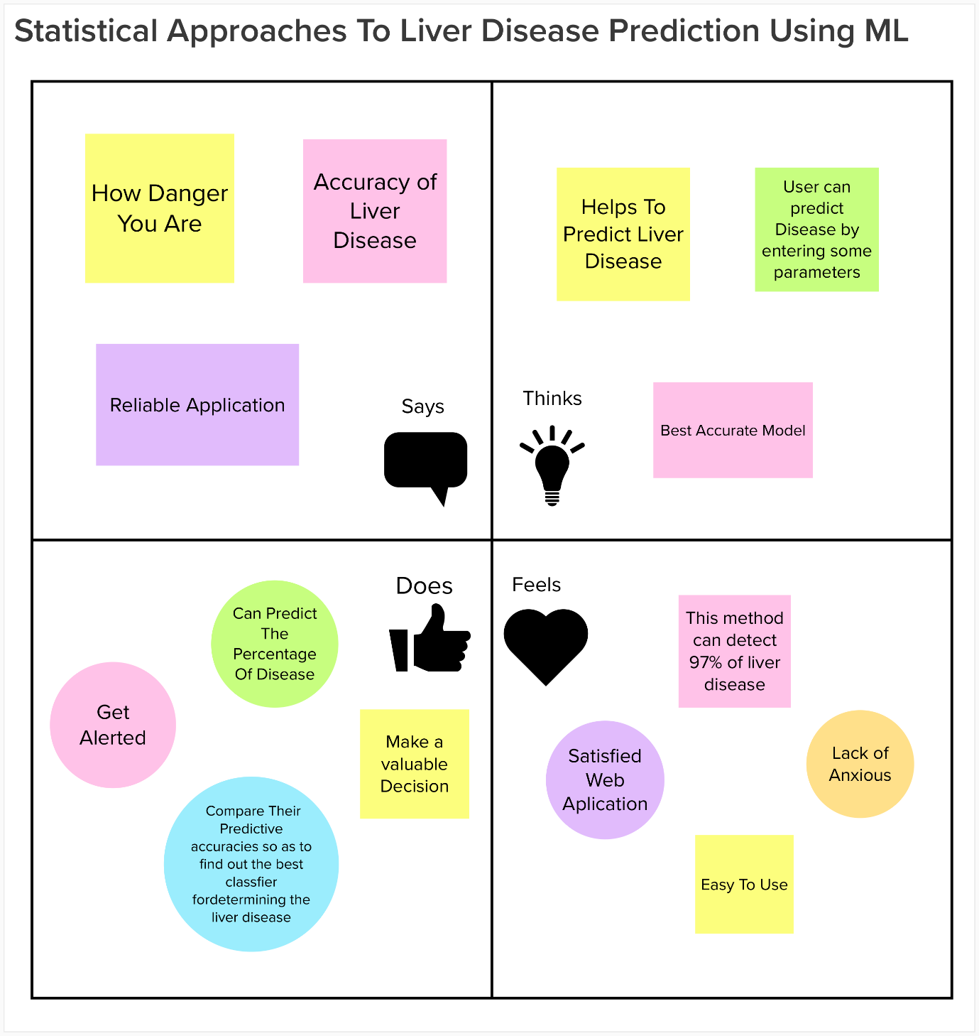

Reference: https://app.mural.co/t/statisticalapproachestoliver1458/m/statisticalapproachestoliver1458/1663504973570/e221689323c491c8512ebda8fdd3740863d165f2